# Thinking in React

* React apps are broken into many reusable parts – these are called components.
* Components are reusable and can be places more than once.
* Components can be nested – you can put components inside other components.

Below is a simplified example of how we can take a page and create it using smaller reusable components.

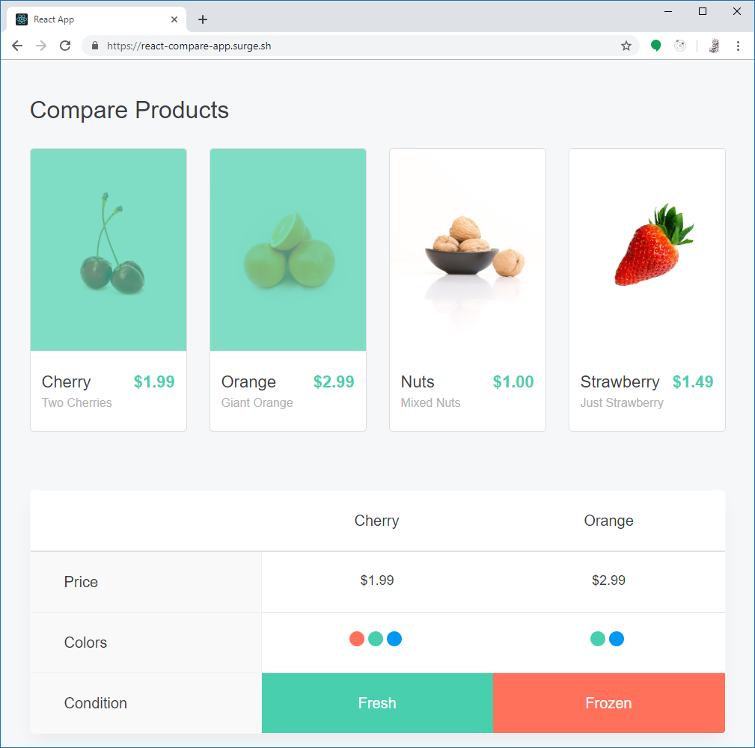

Each colour represents a different component. Elements with the same colour represent a component being reused.

## Wireframing

* A wireframe is a visual guide for an interface that shows what elements will appear on a page.
* They aim to:
  + Show the content and functionality of the page.
  + Help designers communicate with clients on the design concept.
  + Establish the information hierarchy of the page.
* It’s a ‘blueprint’ for a page - you can design the layout and user journey for a site before actually building it.

The below example shows how an online shopping website could be wireframed. In place of images and icons, placeholders are used. This wireframing process allows for fast design iterations, with the designs able to be shared with stakeholders before development commences.

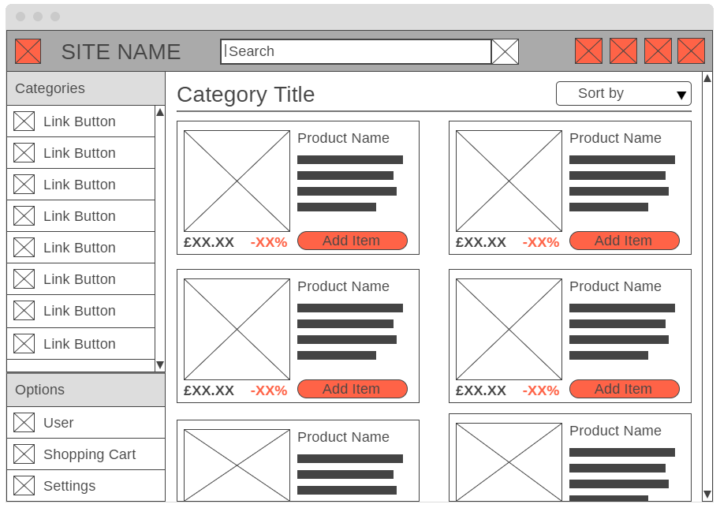

The same process used before can be applied to this wireframe, where elements of the page can be broken into modular React components, like so:



This provides a logical hierarchy of components, with elements like the products nested inside a product list component. This hierarchy is more apparent when displaying the relationships of components like so: